P1 Report
The command you used to compile the program:
clang++ Subtask2.cpp -o Subtask2
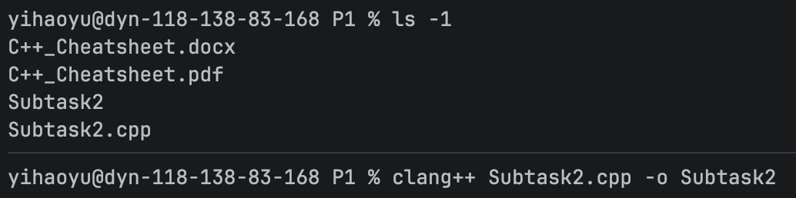
The command you used to run the program:
./Subtask2
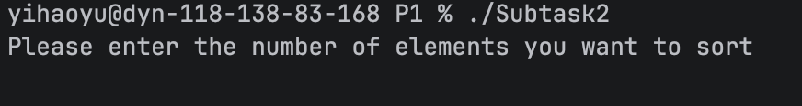
Entering the input and the program printing the output:
